WBA T-Ball 2023 Rules
This is T-Ball and NOT coach pitch and needs to stay as T-Ball even if any players can hit a thrown ball or not.

Length of games
- Games will be 1 hour 45 mins long or 3 innings, whichever comes first
Defensively
- All players play in the field each inning
- All players will be rotated between positions each inning
- Pitcher’s mound will have a player as well but only for defense
- Coaches will be in the field to help instruct the players
- Even if a player is out on a defensive play they will still stay on base
Batting
- All players will bat every inning
- Players will hit off a Tee from home plate
- Players will get as many swings as they need to put the ball in play
- When a ball is put in play the batter will run one base only
- The last batter in the lineup will run ALL bases when the ball is put in play
- Batter positions will be rotated each inning, so the same player is not the last batter each inning
Soft Toss (at the ¾ mark of the season)
At the ¾ mark of the season, 6-7 games in, teams may go to soft toss for batters.
- Soft toss is:
  - Coach sites on the opposite side of the plate
  - Coach tosses the ball underhand to the batter
  - 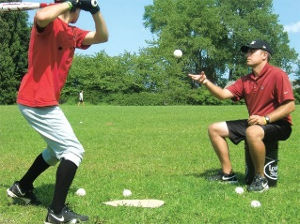
- Soft toss in NOT:
  - Coaches pitching to the batters
  - Coaches halfway up the line throwing at the batter
Rules for batters when doing soft toss
- Batter will get 3-4 soft tosses
  - If the batter does not put the ball in play after 3-4 good soft tosses
    - A tee is brought back up and the batter hits off the tee.
    - Next time at the plate the batter still gets the 3-4 soft tosses

